File IO
File io can be defined as a package which contains classes and interfaces and is responsible to move the content from source to destination through the network.

Text
Network

Source Destination

- Within the network we have to create channel or stream.
- A Channel can be defined as a medium used for data transfer.
- Stream can be defined as sequence of a data or information.

There are two types of stream channel supported by java
- Byte Oriented Stream Channel
- Character Oriented Stream Channel
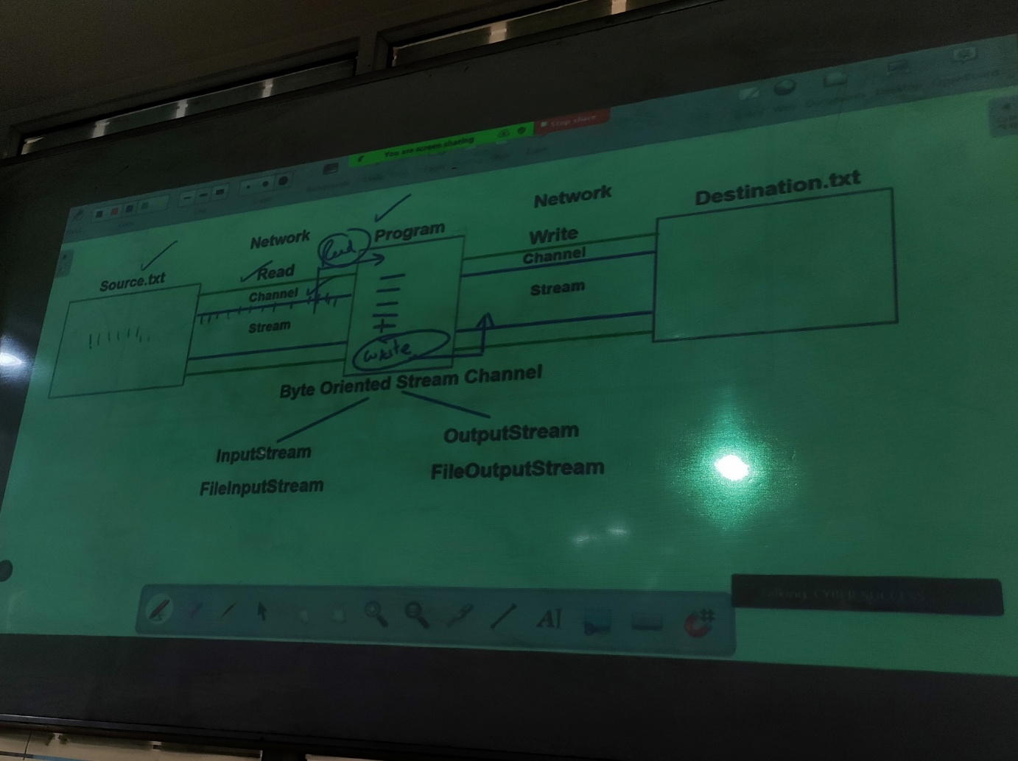

Byte Oriented Stream Channel
Both stream channels will have two perform two operation 1. Read operation 2. Write operation
To perform read and write operations we need to open the channels by creating object. Hence java supports two classes
- InputStream
- OutputStream
InputStream and outputStream by default are abstract hence we cannot create an object so we prefer to go for subclasses or child classes and they are FileInputStream, FileOutputStream
ByteStreamChannel: To read from a file it is mandatory that we create a file but to perform write operations it is not mandatory to create a file because if you don’t create a file then java will automatically create a file.
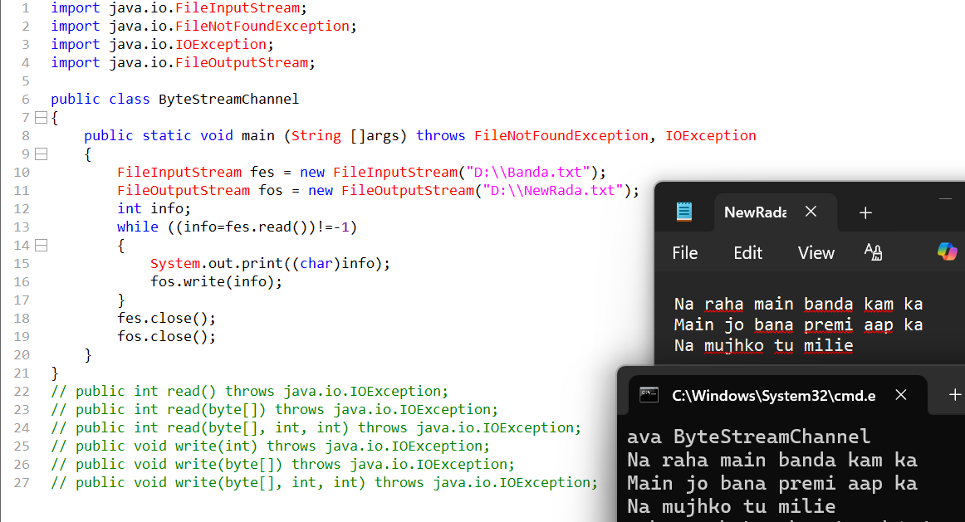

Character Oriented Stream Channel
- Character oriented stream channel both supports read and write operations.
- To perform read and write operations it supports two classes Reader class and Writer class.
- Both reader and writer class both by nature are abstract, hence we go for subclasses or Child classes.
- Hence, we will go for the FileReader and FileWriter classes.
Challenges faced under regular streams
- To read the content from a text file for every character and byte the request has to be sent from the ram to hard disk and for every execution number of times the hard disk will be hit from the ram part of memory. Due to this it will not only consume time but will also degrade the performance of execution. Hence to improve this we prefer to go for buffered streams
- To use Buffered Streams, we at least once need to depend on regular streams
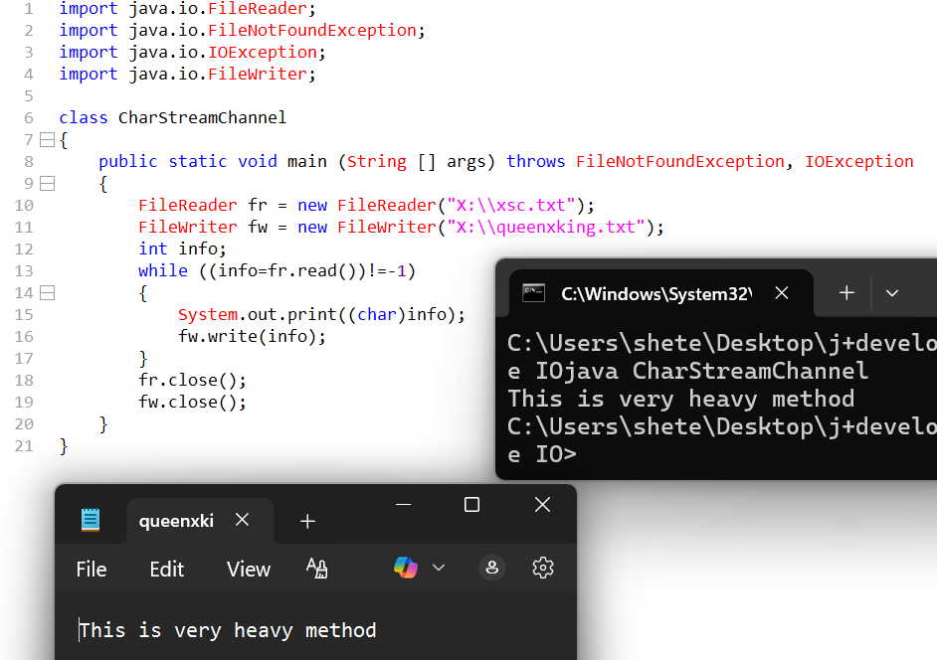
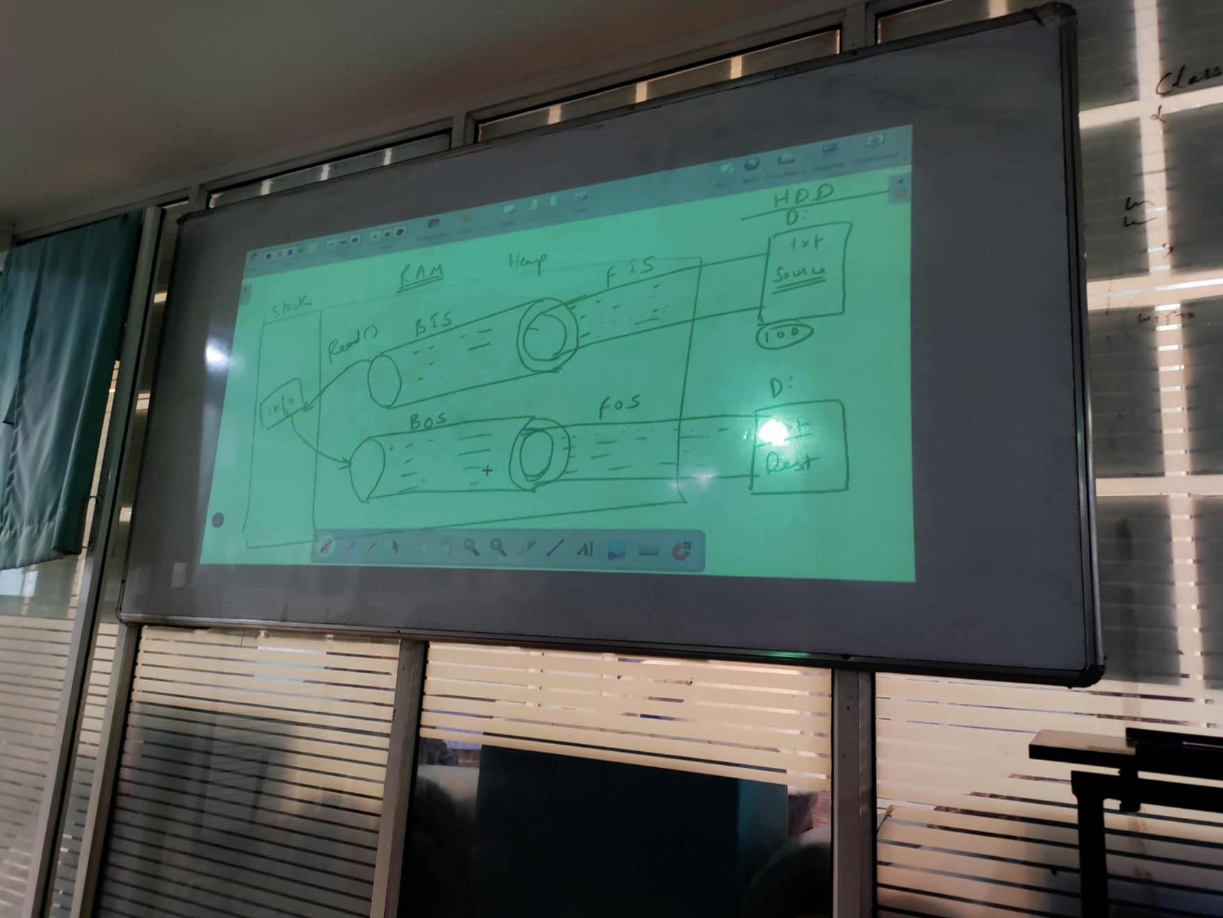

Buffer streams further can be categorized into two types
- Buffered Byte oriented stream channel
- Buffered Character oriented stream channel
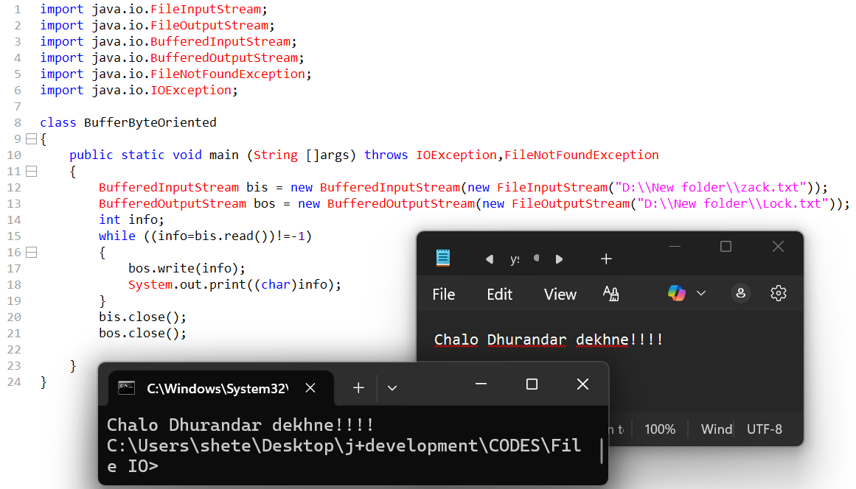
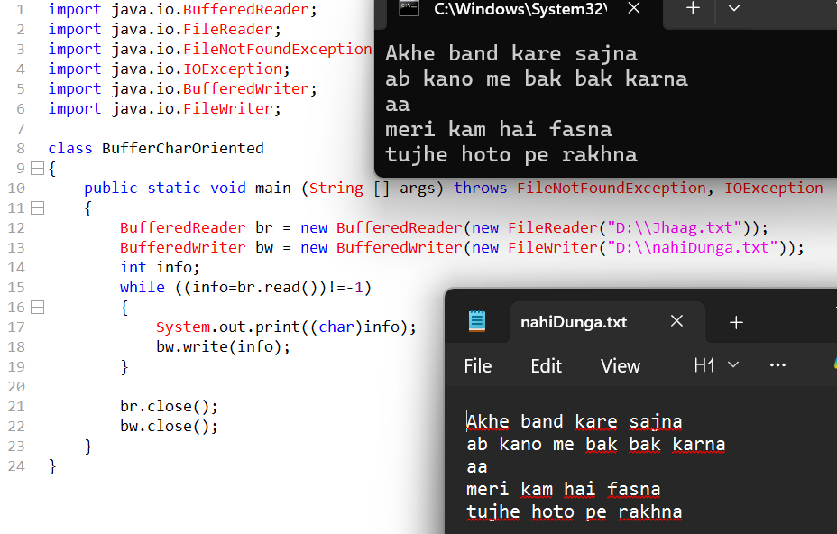

Serialization / Deserialization
- Serialization is a process of converting an object into a network supported format such a process is called as Serialization.
- To achieve the above we need to perform write operation.
- To read an object from network support format such a process is called as Deserialization.
- To achieve the above we need to perform read operation.

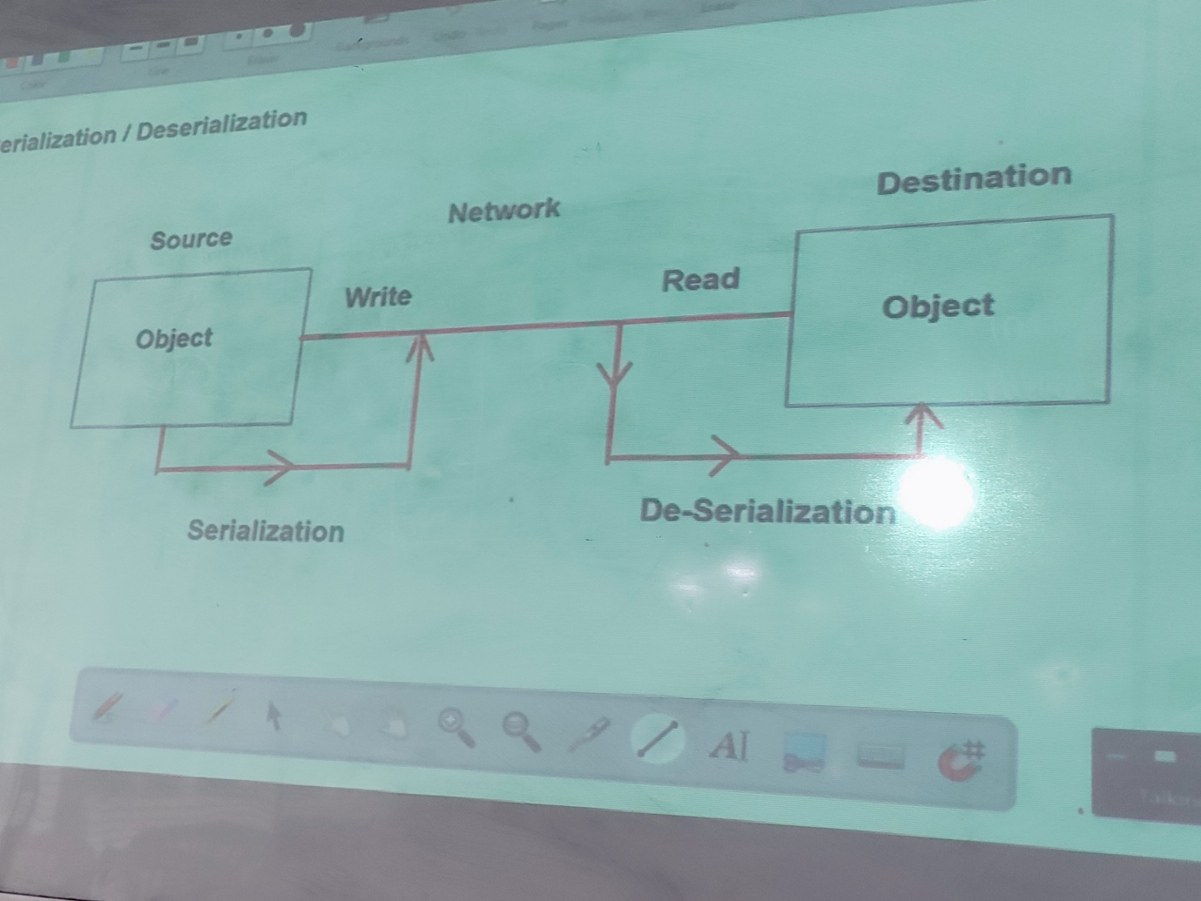

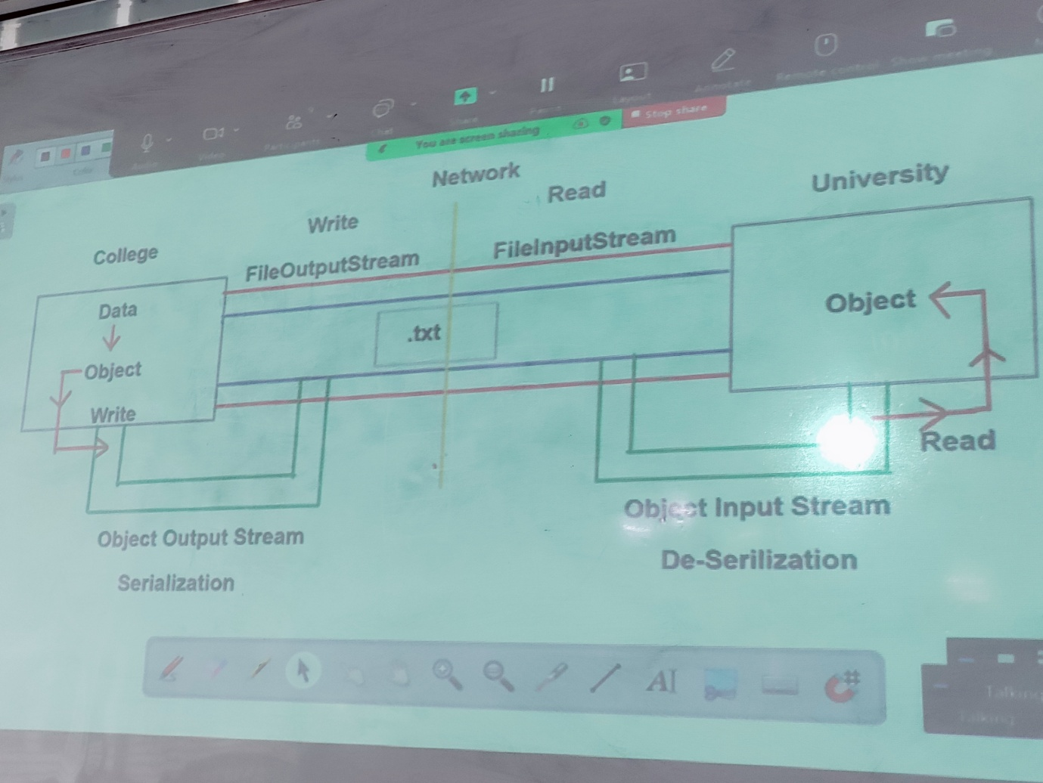

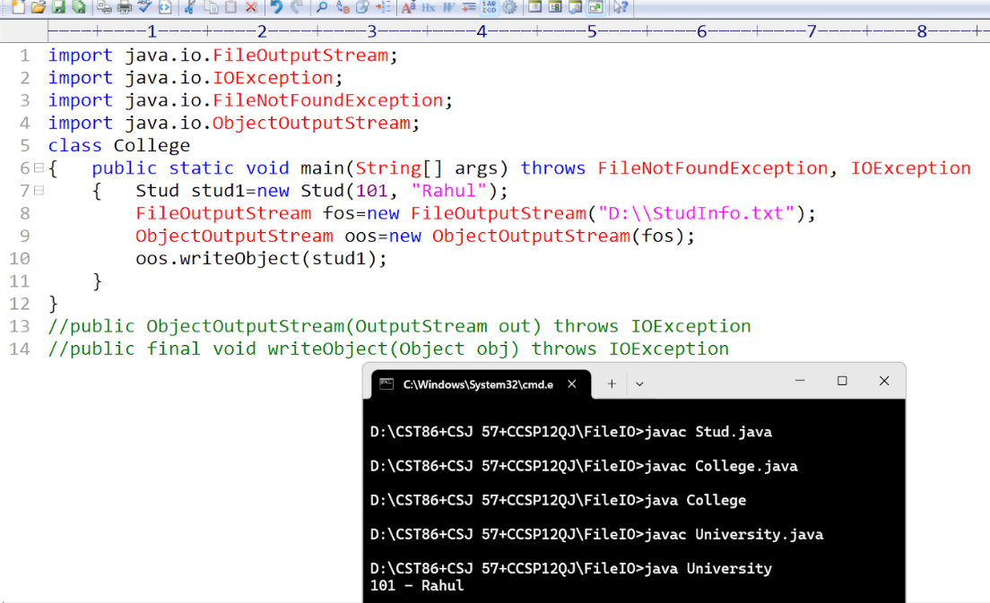
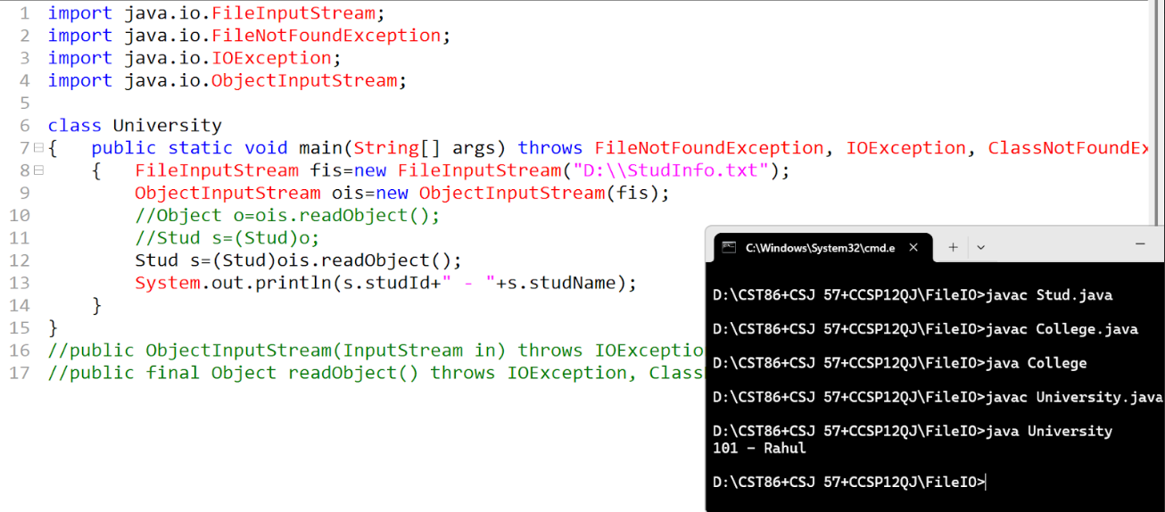

- What is Transient? When do we use Transient modifier
  - Transient is a modifier, whenever we do not want any data to be serialized, we use modifier called as Transient.
- 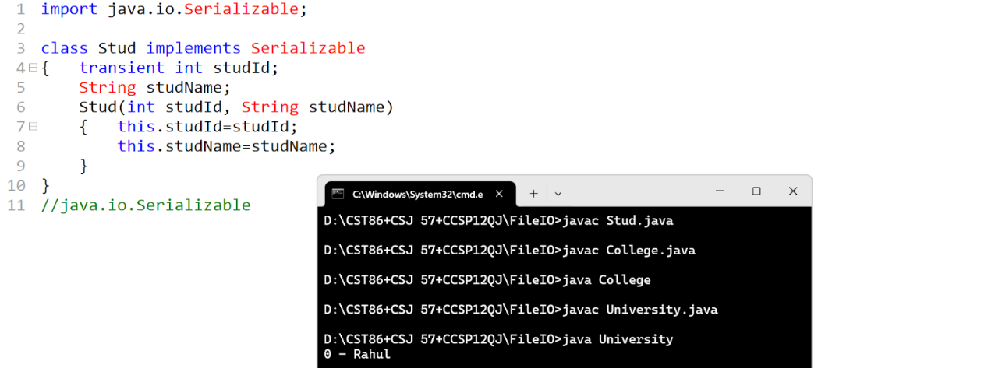

Scanner classes
Scanner classes are responsible to scan or read inputs from various sources like
- String
- File
- InputStream
- Console/Keyboard
Scanner class is part of java.util package.
The Scanner will read any content token by token
Scanner while reading will have to perform two operations:
- Check whether next token is present or not this can be achieved using hasNext()
- If the token is present then to extract the token there is method called as next()
The Scanner by default involves spaces as delimiter.
System.in
System Is a class which represents input and output operations within the machines and out is a reference variable which will make the java display or print the content with help of output stream to console.
System.in is a reference variable which represents the reading or input operations from console to java.
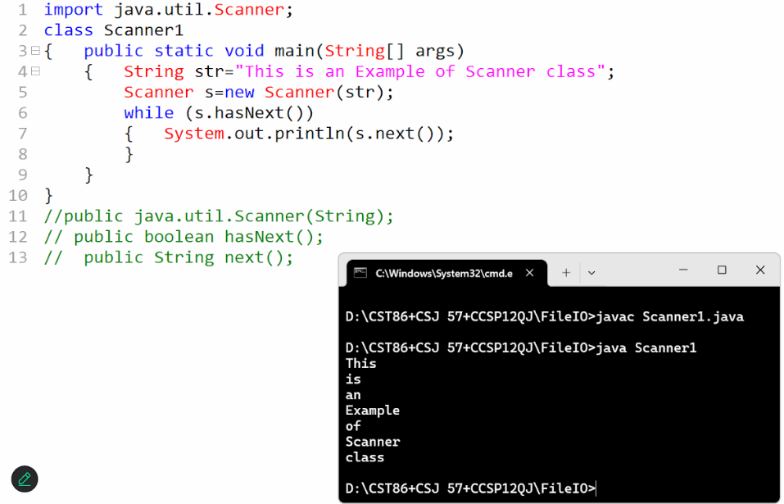
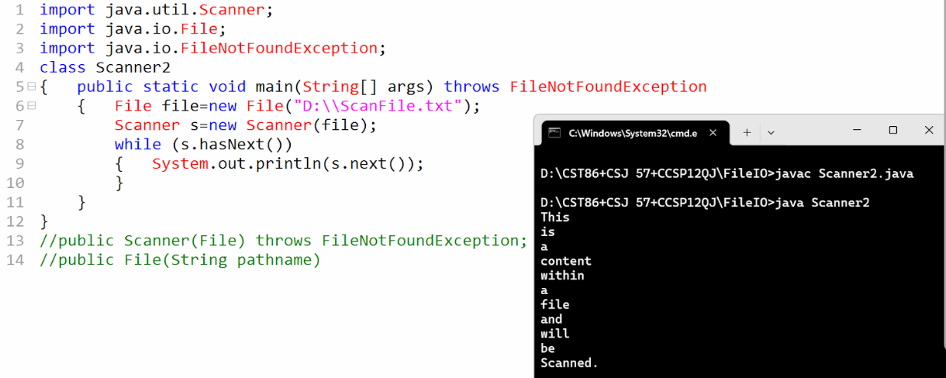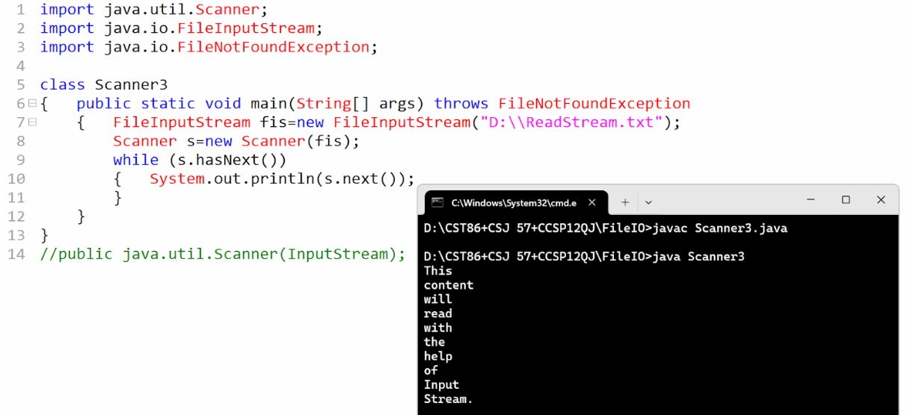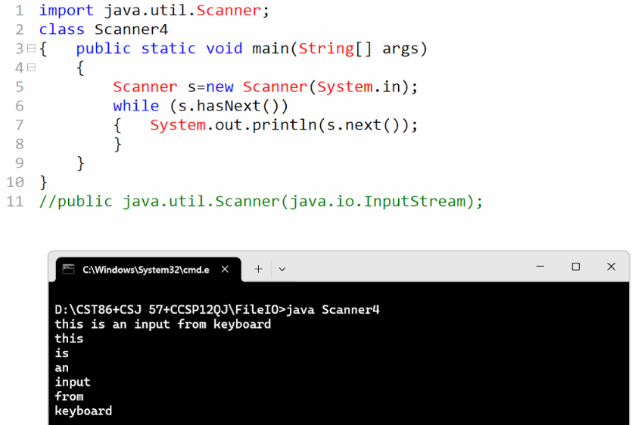
Write a java program to accept two inputs from user and perform the operation and display the output.
